To build source code in Visual Studio

Prerequisites:

1. VS2012
2. WP8 SDK ( <http://developer.windowsphone.com/en-us/downloadsdk> )

In Visual Studio (VS 2012), open the project solution (TapIt-WP8-TestApp.sln).

1. On the Standard toolbar, select a target.
   1. To deploy your app to the emulator, select one of the emulator options.
   2. To deploy your app to a connected device, select the Device option.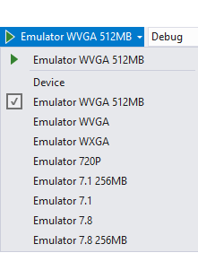
2. To deploy and run your app with debugging, on the Debug menu, click Start Debugging, or press F5.
3. To deploy and run your app without debugging, on the Debug menu, click Start without Debugging, or press Ctrl+F5
4. Your app is deployed and started
5. To deploy your app without running it, on the Build menu, click Deploy Solution.

**To stop a running app (in Debug mode)**

To stop a running app, do one of the following:

* In Visual Studio, on the Debug menu, click Stop Debugging, or press Shift+F5.
* In the emulator or on the phone, press the Back button (Hardware Key) to exit the app. If the active page of the app was not the app’s start page, you may have to press the Back button more than once.
* The app exits and the Start screen opens. This ends the current debugging session.

**To restart an app without debugging**

1. In the emulator or on the phone, on the Start screen, swipe left to view the app list.
2. In the app list, tap the app icon. The app restarts without debugging.

**Steps to Deploy XAP File in a Windows Phone Emulator**

1. Install the Windows Phone SDK 8 Tool.
2. The Windows Phone SDK comes with a utility named “Application Deployment”.
3. launch the Application Deployment utility.

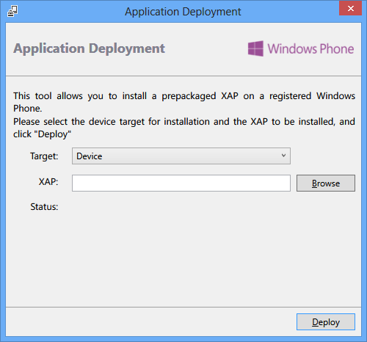

1. Once you select the proper target from the above screen, click “Browse” to select the XAP file that you want to deploy either in your physical device or phone emulator. Now click “Deploy” button to start the deployment process.
2. Once it has been deploy successfully, you will see a success message; then you can close this window.
3. Now you open your device or emulator to see the installed application in the application list.

**Test Application snapshots**  